Appendix C: IEEE 830 Template
Software Requirements Specification
for
«Campus Focus Room (Study Booth) Booking System»

Version «1.0.2»
Prepared by «Norbert Fila»
«LODZ UNIVERSITY OF TECHNOLOGY - IFE»
«10.03.2026»
«Page Break»
Table of Contents
«Table of Contents»
Revision History
Name | Date | Reason for Changes | Version
«Norbert Fila» | «10.03.2026» | «Initial Version» | «1.0.0»
Norbert Fila | 17.03.2026 | Added Use Case UML Diagram [Sec 3.0], Hardware Interfaces [Sec 4.2] and Administrator user class [Sec 2.3] | 1.0.1
Norbert Fila | 24.03.2026 | Added UML Class Diagram [Sec 4.3] | 1.0.2
«Page break»
1. Introduction
1.1. Purpose
«The purpose of this document is to specify the software requirements for the Focus Room Booking System, Version 1.0.2. This Software Requirements Specification provides a comprehensive description of the system's core capabilities. It covers the entire scope of the initial product, which includes user authentication, real-time room availability tracking, booking limit enforcement, and authentication.»
1.2. Document Conventions
«This document adheres to the IEEE Std 830 guidelines for Software Requirements Specifications. . Every functional and non-functional requirement is assigned a unique identifier (e.g., REQ-1.1, NF-1.1) to ensure full traceability. It is assumed that every requirement statement possesses its own priority and operates as an independent, testable unit.»
1.3. Intended Audience and Reading Suggestions
«This document is intended for a diverse audience involved in the lifecycle of the Focus Room Booking System. The primary readers and suggested reading sequences are as follows:
Project Managers and Stakeholders: Should review Section 1 (Introduction) and Section 2 (Overall Description) to gain a comprehensive understanding of the product scope, business objectives, and system context.
Software Developers and Architects: Should focus heavily on Section 4 (External Interface Requirements), Section 5 (System Features/Modules), and Section 6 (Nonfunctional Requirements) for detailed technical specifications required for system implementation.
Quality Assurance (QA) and Testing Teams: Should utilize Section 5 and Section 6 as the definitive source for developing test plans, test cases, and validation procedures based on the specified functional and non-functional criteria.»
1.4. Product Scope
«The Campus Pod Booking System is a centralized web application designed to manage the reservation of soundproof study booths across the university. Currently, the lack of a structured reservation process for these individual units is causing significant frustration among students.
The primary objective of this system is to optimize resource utilization by providing a transparent, automated booking workflow. Key benefits include real-time availability tracking of individual pods, prevention of double-booking, and automated reservation release based on physical booth occupancy sensor data.
By ensuring equitable access to quiet study environments and eliminating scheduling conflicts, the software directly aligns with the university's goal of providing a highly efficient and supportive academic infrastructure.»
1.5. References
«
- Juwaied, A. (PhD.). "Software Engineering LAB 1: REQUIREMENTS ANALYSIS". Lodz University of Technology - IFE.
- IEEE Computer Society. "IEEE Recommended Practice for Software Requirements Specifications" (IEEE Std 830-1998).
»
2. Overall Description
2.1. Product Perspective
«The Campus Pod Booking System is a new, self-contained software solution designed to manage a distributed network of acoustic study booths located throughout the university campus.
Unlike traditional room-booking tools, this system focuses on high-density, autonomous pods that provide soundproof environments for individual work. Currently, students and staff struggle to locate these units or verify their occupancy in real-time, often finding them occupied without a formal schedule.
The proposed system provides a centralized platform allowing users to pinpoint available pods via a mobile-friendly interface and reserve them for specific time slots. The system operates as a web-based application, optimized for mobile browsers to support "on-the-go" reservations. It manages unit availability, synchronization with on-site sensors, and administrative control over the entire booth fleet.
The system is intended to maximize the utilization of these specialized campus resources and provide a structured, friction-less method for accessing private study modules.
»
2.2. Product Features
- Viewing available focus rooms on campus
- Displaying the availability schedule for each room
- Reserving a focus room for a selected time slot
- Viewing and managing user reservations
- Canceling existing reservations
2.3. User Classes and Characteristics
«Students represent the primary user group of the system.
They will use the system to find available focus rooms and make reservations for studying or individual work.
Characteristics:
- basic technical knowledge
- frequent system usage during the academic semester
access through mobile devices or laptops
Administrators represent the secondary user group of the system. They will use the system to manage the study booth catalog, monitor user reservations, and oversee daily operations.
Characteristics:
- periodic system usage during administrative working hours
- system usage focused on daily management during regular office hours
»
2.4. Operating Environment
«
The system shall operate in the following environment:
web application accessible through all modern browsers, working well on mobile and dekstop.
The system will be hosted on a university server or cloud infrastructure.
»
2.5. Design and Implementation Constraints
«
- The development of the system may be limited by the following constraints:
- the system must operate through standard web browsers
- access to the system requires valid university authentication credentials
- the system must support multiple concurrent users during peak academic hours
- the system must follow university data privacy and security policies
»
2.6. User Documentation
«
The following documentation will be provided to support system users:
- a user guide explaining how to create and manage reservations
- an administrator manual describing how to manage rooms and reservations
- online help documentation available within the application
Documentation will be delivered in digital format as web sub-page.
»
2.7. Assumptions and Dependencies
«
The system requirements are based on the following assumptions:
- users have valid university accounts for authentication
- focus rooms are physically available on campus
- the university provides server infrastructure or hosting for the system
- users have internet access to interact with the application
»
3. System Features
3.0. «Use Case Model»
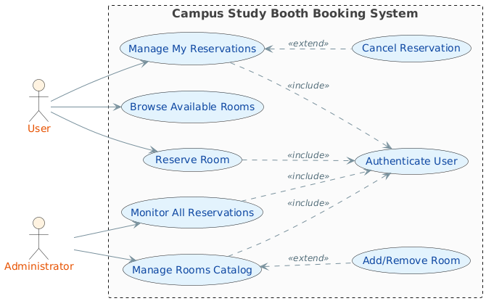
3.1. «Room Browsing»
«The system shall allow users to view available focus rooms located on campus.
Users shall be able to check room availability for specific dates and time slots before making a reservation»
3.2. «Room Reservation»
«The system shall allow users to reserve a focus room for a selected time period.
The reservation feature ensures that rooms cannot be booked by multiple users at the same time»
3.3. «Room Management»
«The system shall allow users to view and manage their reservations.
Users shall be able to cancel reservations or review previously booked time slots.»
3.4. «Administrative Management»
«The system shall allow administrators to manage focus rooms and reservations.
Administrators shall be able to add new rooms, update room information, and monitor existing reservations.»

3.«N». «Additional feature blocks as needed»
4. External Interface Requirements
4.1. User Interfaces Overview
«The system shall provide a graphical user interface (GUI) accessible through a web browser. The interface will allow users to interact with the system through standard graphical elements such as buttons, menus, forms, and calendar views.
Users shall interact with the system through the following screens:
- Login Screen - users enter their university credentials to access the system.
- Room List Screen - displays available pods and basic room information.
- Availability Schedule Screen - shows available time slots for each room using a calendar-style interface.
- Reservation Screen - allows the user to select a time slot and confirm a reservation.
- My Reservations Screen - displays the list of reservations made by the user.
Administration Panel - available only to administrators for managing rooms and reservations.
Users shall interact with the interface using common actions such as:
- clicking buttons
- selecting time slots from a calendar view
- entering information into form fields
- navigating through menus
The interface shall provide immediate feedback to the user after each action. For example:
- confirmation messages after successful reservations
- error messages when a selected time slot is already reserved
- notifications when a reservation is canceled
The interface shall follow standard usability principles and provide a clear layout that allows users to complete a reservation quickly.
Minimum interface requirements include:
- consistent screen layout across all pages
- clearly labeled navigation buttons
- visible error messages for invalid inputs
- confirmation messages after system actions
- responsive design to support both desktop and mobile devices
»
4.2. Hardware Interfaces
«The System shall interface with the existing hardware infrastructure integrated into each study booth. The system acts as a management layer that processes data from embedded sensors and pushes reservation status updates to the local displays.
Occupancy Data Integration
The system shall ingest real-time data from the booths' existing occupancy sensors (such as PIR motion detectors or door contacts).
- The system shall monitor the "Occupied/Vacant" signal sent by the unit's controller.
- This data shall be used exclusively for reservation management: if a reserved pod does not report a "Physical Occupancy" signal within 10 minutes of the booking start time, the system shall trigger an automatic release of the slot.
External Status Displays
The system shall serve as the data provider for the electronic display panels mounted on the exterior of each booth.
- Data Push: The system shall update the display's API every time a reservation status changes.

- Visual Output: The system shall provide the display with the current availability state (Available / Reserved / Occupied) and the timeline of upcoming bookings.
Connectivity Interface
- The application shall communicate with the booth controllers via the university’s local area network (LAN/Wi-Fi).
- The system is responsible only for the logical synchronization of the reservation database with the physical state of the unit; it does not control internal booth functions such as lighting or climate settings.»

4.3. Software Interfaces
To provide a clear overview of the system's internal structure and data organization, the following Class Diagram illustrates was created.

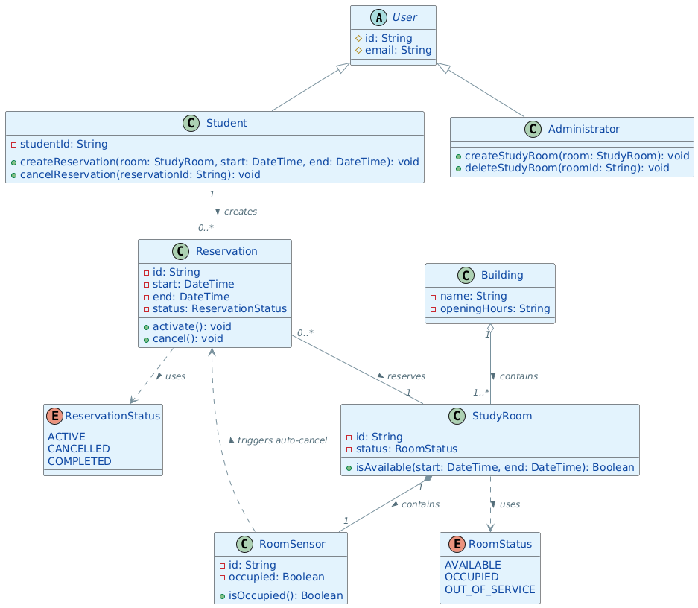
«The Campus Pod Booking System shall interact with several external software components that support authentication, data storage, and system communication.
University Authentication Service
- The system shall interface with the university authentication service to verify user identities during login - and return the authentication result to the system.
The system shall receive the following data from the authentication service:
- user identifier (User ID)
- authentication status
- user role or access level
The system shall not store personal user data such as names, emails, or passwords. Only the unique user identifier provided by the authentication system shall be stored for reservation tracking purposes.
The system shall interface with a database management system used to store reservation-related data.
The database shall store only operational information required for system functionality, including:
- reservation identifier
- room identifier
- reservation start time
- reservation end time
- user identifier associated with the reservation
- reservation status
No personal user information shall be stored in the system database.
The application shall communicate with the database using standard database queries to retrieve and update reservation information.
The database shall store:
- Reservation Metadata: Unique reservation ID, start/end timestamps, and current status.
- Unit Identifiers: Unique IDs for each physical study pod.
- Audit Logs: The User ID associated with each booking.
»
5. System Features/Modules
«This template illustrates organizing the functional requirements for the product by system features, the major services provided by the product.»
5.1. «Room Status Check»
5.1.1 Description and Priority
«This feature allows users to view the availability of focus rooms before making a reservation.
Users can check which rooms are free and see available time slots.
Priority: High»
5.1.2 Stimulus/Response Sequences
«
Stimulus: The user requests the list of available focus rooms.
Response: The system displays the list of focus rooms with their availability status.
Stimulus: The user selects a specific focus room.
Response: The system displays the reservation schedule for the selected room.
»
5.1.3 Functional Requirements
«Itemize the detailed functional requirements associated with this feature. These are the software capabilities that must be present in order for the user to carry out the services provided by the feature. Include how the product should respond to anticipated error conditions or invalid inputs. Requirements should be concise, complete, unambiguous, verifiable, and necessary. Each requirement should be uniquely identified with a sequence number or a meaningful tag of some kind.»
REQ-1.1: «Upon a user request, the system shall display a list of all available focus rooms.»
REQ-1.2«Upon selecting a focus room, the system shall display the reservation schedule for the selected room.»
REQ-1.3«The system shall indicate whether a room is available, reserved, or occupied.»
REQ-1.4«The system shall update room availability information after each reservation or cancellation.»

5.2. «Room Reservation»
5.2.1 Description and Priority
«This feature allows users to reserve a focus room for a selected time slot.
The system ensures that a room cannot be reserved by more than one user at the same time.
Priority: High»
5.2.2 Stimulus/Response Sequences
«
Stimulus: The user selects an available room and time slot.
Response: The system creates a reservation and confirms the booking.
Stimulus: The user selects a time slot that is already reserved.
Response: The system displays an error message indicating that the slot is unavailable.
Stimulus: The user requests to view their reservations.
Response: The system displays the list of reservations associated with the user's identifier.
Stimulus: The user requests to cancel a reservation.
Response: The system removes the reservation and updates the room availability.
»
5.2.3 Functional Requirements
REQ-2.1: «Upon a reservation request, the system shall verify whether the selected room and time slot are available.»
REQ-2.2«If the selected time slot is available, the system shall create a reservation record.»
REQ-2.3«The system shall assign a unique reservation identifier to each reservation.»
REQ-2.4«If the selected time slot is already reserved, the system shall reject the reservation request.»
REQ-2.5: «Upon a reservation request, the system shall verify whether the selected room and time slot are available.»
REQ-2.6«Upon user request, the system shall display all reservations associated with the user identifier.»
REQ-2.7«Upon a cancellation request, the system shall delete the corresponding reservation record.»
REQ-2.8«After a reservation is cancelled, the system shall update the room availability status.»

6. Nonfunctional Requirements
6.1. Performance
NF-1.1: «The system shall respond to user interface requests within 2 seconds under normal operating conditions.»
NF-1.2«N»: «The system shall support at least 5000 concurrent users without performance degradation.»
NF-1.3.«N»: «The system shall update room availability information within 5 seconds after a reservation is created or cancelled.»
NF-1.4«N»: «The system shall process reservation requests within 3 seconds after submission.»

6.2. Security
NF-2.1: «The system shall authenticate users using the university authentication service before allowing access to reservation features.»
NF-2.2«N»: «The system shall store only a unique user identifier associated with each reservation and shall not store personal user information.»
NF-2.3«N»: «The system shall transmit all user requests and responses using secure HTTPS communication.»

6.3. Reliability
NF-3.1: «The system shall maintain 99.5% uptime during the academic semester.»
NF-3.2«N»: «The system shall prevent double booking of the same focus room during overlapping time slots..»
6.3. Usability
NF-4.1: «A first-time user shall be able to complete a room reservation within 2 minutes.»
NF-4.2«N»: «The system interface shall display clear confirmation messages after successful reservations.»

